<Project Name>
<Project Name>

Author
<Project Name>

Design Final Report

Project Partners: Mr. John-Ross Torre, Jacobs Engineering Group Inc.

Demonstrator: < Catherine Hatch >

Academic Supervisor:
< Sally Male>

Word Count: 2653
Word Limit: 3500

Version <1.3>

Revision History
Date | Version |  | Description | Author
11/05/17 | 1.0 |  | Format and insert drafts into temple, begin editing | Xiaobin LIN
13/05/17 | 1.1 |  | Continue editing, and create additional content to improve flow | Xiaobin LIN
14/05/17 | 1.2 | Continue editing, and create additional content to improve flow |  | Xiaobin LIN
16/05/17 | 1.3 | Final Edit |  | Xiaobin LIN

Table of Contents
1. Introduction 4
1.1 Scope 4
1.2 Overview of submission 4
1.3 Definitions, Acronyms, and Abbreviations 4
1.4 References 4
2. Summary of Contribution 5
3. Design Methodology 5
4. Sizing the system component 7
5. Updated the requirements table 9
6. Evidence of Teamwork 10
6.1 Design Review 11
7. Analysis and Evaluation 12
8. Individual Learning Outcome 12
9. Appendices 14
9.1 Appendix A: Updated Requirements Priority Table including Classifications. EXP - Expecters, SPO - Spoken, UNS - Unspoken, EXC - Exciters 14
9.2 Appendix B: Climatic Information at Newman, WA 15
9.3 Appendix C: Technical Query 16
Table of Figures
Figure 1: Average daily sunshine hours annual 6
Figure 2: Fully RES Model line diagram 6
Figure 3: Solar Radiation 8
Figure 4: Client Proposed Requirements 13
Figure 5: Base Case Line Diagram 14
Figure 6: Hybrid System line diagram 14
Figure 7: Design Project Workflow 15
Table of Tables
Table 1: Required System Components 8
Table 2: PV efficiencies [2] 9
Table 3: TSM-23--DC05 PV panel specifications 9
Table 4: List of the relevant requirements 11
Table 5: List of relevant Assumptions 11
Table 6: Resource Table 12
Table 7: Four Design Options 13
Table 8: Maximum Load (By using Grundfos MMS6000 Series) 13

Solar Generation for Remote Boreholes
Design Final Report

Introduction
This project is to design a power system to supply 90KW to three bore pumps situated 10 km from the mine site. The requirement of this power system (Appendix: A) must operate and supply constant power 24/7. And a cost-effective method needs to be derived to satisfy the requirement of this project.

Scope
This report represents a fully renewable energy system (RES) design option of “Solar Generation for Remote Boreholes” project created by Jacobs Engineering Group Inc. The scope of this document covers the author contribution to the project, not only a proposed RES model and sizing PV modules, but also testing and outline each system structure etc.

Overview of submission
The overall intention of this report is to outline a design solution, and sizing the system component which are used in the completion of the project. The report is introduced including the scope of the document and outline what is covered as a whole. A summary of the contribution to this report is provided. When justifying design decisions, this included solar, wind, location, battery storage etc. A discussion of how well they would potentially meet the project requirements along with any trade-offs between requirements was conducted. Also sizing the system would be conducted to address a feedback from the design review meeting and test the feasibility of the design decisions. Also, evidence of teamwork and individual learning outcome would be provided in the end.

Definitions, Acronyms, and Abbreviations
Abbreviation | Definition
RA | Requirement Analysis
RES | Renewable Energy System
PV | Photovoltaics
DC | Direct Current
AC | Alternating Current
HOMER | Hybrid Optimization Model for Electric Renewables
NPV | Net Present Value
WBS | Work Breakdown Structure

References
[1] "Australian Climate Averages - Sunshine Hours", Bom.gov.au, 2017. Available: http://www.bom.gov.au/jsp/ncc/climate_averages/sunshine-hours/index.jsp
[2] Anon, (2017). 1st ed. Available: http://www.fanarco.net/books/misc/Wind_and_power_Solar_System.pdf
[3]"Solar Inverters and. Electrical Balance of System - PDF", Docplayer.net, 2017. Available: http://docplayer.net/42551071-Solar-inverters-and-electrical-balance-of-system.html
[4] T. Lambert, P. Gilman, P. Lilienthal, T. Lambert, P. Gilman, and P. Lilienthal, Micro-power System Modelling with Homer. John Wiley & Sons, Inc., 2006, pp. 379-418.
[5] "HOMER - Hybrid Renewable Micro-grid System Design Software", Homerenergy.com, 2017. Available:
http://www.homerenergy.com/HOMER-getting-started-guide.html
[6] A. Shiroudi et al., "Case study: Simulation and optimization of photovoltaic-wind-battery hybrid energy system in Taleghan-Iran using homer software," Journal of Renewable and Sustainable Energy, vol. 4, no. 5, 2012.
[7] S. Hartley, Professional project management: the integration of strategy, operations and change. Prahran, VIC: Tilde University Press, 2014.

Summary of Contribution
Xiaobin LIN, as a team member attends the regular meeting on Tuesday and Friday afternoon, two of these meetings are with the team members and the third includes the team’s academic supervisor and demonstrator. The author, as a minutes-taker to record and sort out the meeting notes and upload on LMS and GitHub in week 5and week 6 and as a chairperson to write an agenda for each meeting and book venues for the meetings in week 7and week 8. Also, the author will be a representative to collect related technical queries of Team 12 and attend the partner meeting at Jacobs in week 11. Moreover, the author has conducted the research of geographical position and climate in Newman, and then determines the most viable renewable energy (Solar and wind). What is more, author has analyzed and wrote the project requirements of safety, economy, telemetry, and maintainable including description of requirement, requirement origin, justification for assigned priorities, and testability (which is NO. 4,5,6,7of Requirement Table in Appendix A). And literature review of solar PV, wind, LNG, and data sheets of Grundfos MMS 6000 have been wrote by the author in requirement analysis (RA). Importantly, the author has done the design option: Solar-Wind-Battery based on Homer. Additionally, the author also organized design review, sorting out the resources table and drawing the line diagrams for each system and collected feedbacks regarding sizing the system components. Finally, the author keeps working on further PV research and analysis.

Design Methodology
The fully renewable proposed solution is to design a renewable energy system combined with storage to decrease dependence on the diesel generator. Each technology has specific requirements to optimize functionality and suitability for the system, for example a solar PV system will work more effectively in areas that have higher solar radiation. Particularly, the available background climate information can be found in the Figure 1, which is high number of sunshine hours around 11at Newman (More details refer to Appendix B [1]). Therefore, solar energy can be considered as one of important sources for this site.
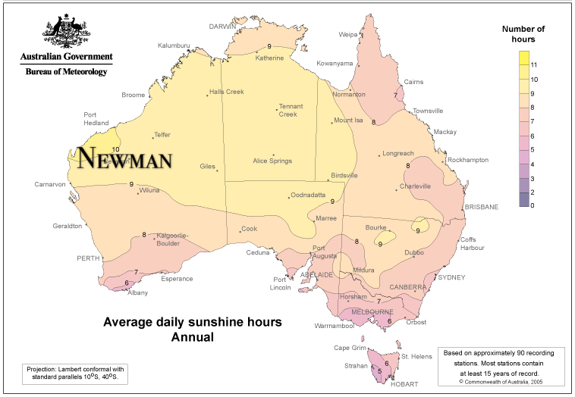
Figure 1: Average daily sunshine hours annual
Additionally, wind energy utilization was chosen in conjunction with PV technology as wind turbine technology advances the efficiency of converting wind energy to electricity increases. Also, based on the abundance of the wind energy source, specifically, the average morning wind speed is 9.1km/h and afternoon is 9.4km/h at Newman [1]. Furthermore, due to renewable sources fluctuation and the insufficient reliability of supply, battery can be considered as backup system to supply the load via storing energy during periods of high energy production brought on by high solar exposure or strong winds. Moreover, this would also include the addition of an inverter as power produced by PV is DC while the pumps require AC power and 100W telemetry system (24Volts DC power) to measure and relay information about the system as a whole to the mine site. Thus, the whole design regarding the RES model can be shown in the Figure 2 and required system components of proposed model shown in table 1;
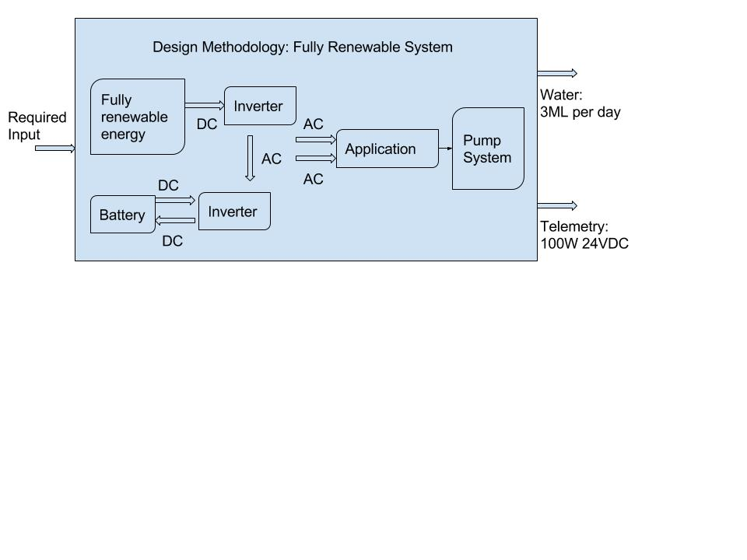
Figure 2: Fully RES Model line diagram

Table 1: Required System Components
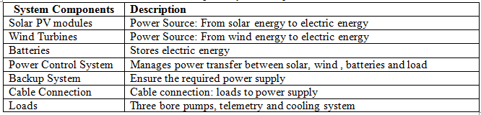

Sizing the system component
4.1 Power Demand
The output of PV system is dependent on the amount of insolation received from the sun, which changes throughout the day and year. To meet the need of consumers, the power requirement of PV system should be considered (Assume the weather situation: there is the worst solar radiation and no wind).
For this project, according to Jacobs’ response to the bore pumps, there are three bore pumps but two pumps on duty and one standby (Appendix C: TQ). Thus, assume the daily minimal power demand of the load is 60KW:
Pumps demand (Considering two pumps):

Additionally, with the use of 100W telemetry system, thus the total load can be calculated as:

,

Per day

4.2 Size the PV modules
The solar radiation of Newman can be obtained via the Homer tool. So considering the worst situation in June (3.98kWh//m²/day), see whether it satisfies the power supply or not.
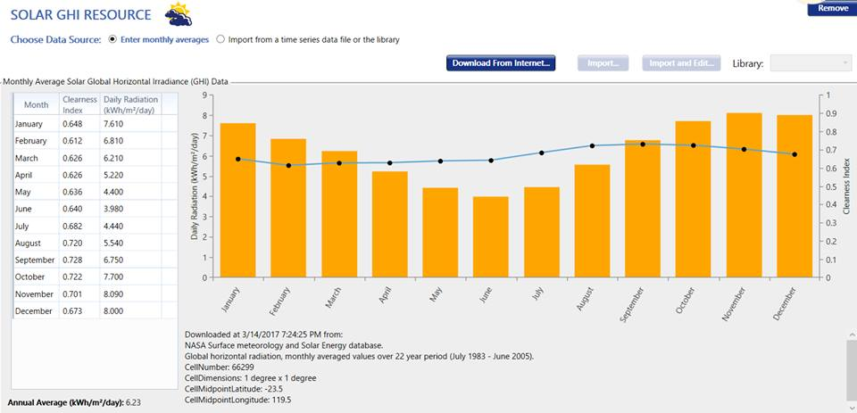
Figure 3: Solar Radiation
Besides, the efficiency of PV system should be considered. This includes the panel derating factor, coulomb efficiency and the inverter efficiency. These efficiencies are used to calculate the power output of the PV system, since losses in the system components decrease the amount of usable energy. The efficiencies are shown below in Table 1:
Table 2: PV efficiencies [2]
Efficiency | Efficiency Value (%)
Delivery Efficiency () | 80%
Inverter Efficiency () | 85%
Coulomb efficiency () | 90%

The total dc load can be calculated as:

Assuming the load is 100% AC the total dc load accounting for inverter efficiency would be 1696.9 KWh. Selecting a nominal DC system voltage of 48V, then the total load (assuming no variation of load by month) is:

Now a PV panel from a manufacturers catalog can be selected, choosing the Trina Solar TSM-DC05 monocrystalline cell from the RFI solar catalog [3] with the following specifications:
Table 3: TSM-23--DC05 PV panel specifications
Rated Power | 230W
Vmp (V) | 29.8
Imp (A) | 7.72
Isc (A) | 8.26
efficiency | 14.1%
Size (mm) LxWxD | 1650 x 990 x 46

The capacity of each string is then:

The number of strings in parallel is:

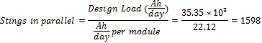

Thus, at lease the system needs to provide 1598 PV modules to meet the power supply when only using solar panels. Because the series connection is easy to influence the whole system when one of the panels is broken, so the parallel connection is recommended. Other system components and connection would be conducted by team members.

Updated the requirements table
A full design requirements analysis for this project has previously been completed. The list of design requirements can be referred in Appendix A: Updated Requirements. Since the submission of the Requirements Analysis document, some changes have been made to the assumptions stated in that document. These affect the details of requirements (NO. 2 and 3), however the actual requirements as defined in the Requirements Analysis and Appendix A remain unchanged. These changes resulted from clarifications from the client regarding power consumed by ancillary equipment and the length of time the backup power supply would be required to operate.
Before the testing of the system, some related requirements and assumptions of this proposed model should be declared ahead of time. With reference to the project requirements document, the following are lists of relevant requirements and assumptions can be shown below:

Table 4: List of the relevant requirements

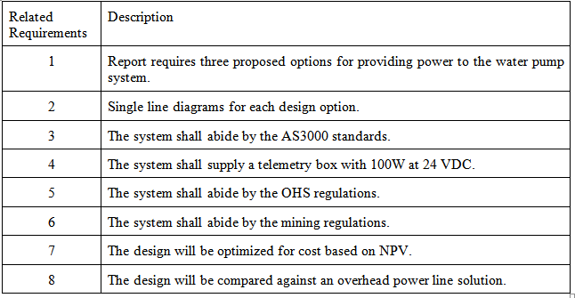
Table 5: List of relevant Assumptions

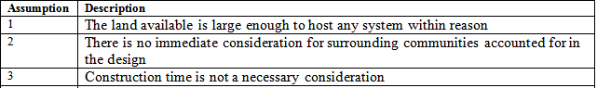

Evidence of Teamwork
Xiaobin, LIN as a member of Team Power has contributed to the team significantly. The author has designed and analyzed a renewable hybrid system model for the Team Power. Also, calculating daily power demand and sizing PV system components, this would be facilitating for group analysis and discussions in terms of proposed system model during the simulation procedure. Additionally, the author has drew the line diagrams for the each system via Google Drawings, which is beneficial for the team to have a clear understanding of the structure of the proposed system models (As shown in Figures 2,5 and 6). Also, author has collected and sorted out all relevant resources, in order to help team to do the design review (Some significant contents would be shown in Section 6.1). At the end of design meeting, the author has compiled feedbacks from Marcus and uploaded on LMS and GitHub, including technical queries would be sent to the project partner and discussed at project partner meetings. This ensures communication with the main external project stakeholder and allows the team to monitor changes in stakeholder and client expectations. Besides, ongoing communication with internal stakeholders is typically in face-to-face meetings with the team members. Once a week, the author presents questions about assessments and project processes to the supervisor and demonstrator. Together with task allocation and scheduling, communication helps the team better complete the project.

Design Review
- Basically, Table 5: resource table represents all the important design inputs:
Table 6: Resource Table
Design Inputs | Three types of energy sources | Energy Storage Technologies | Other Required Technologies
Power Generation Solutions | Base Case:  Overhead Power | Battery Storage | Inverter (100W 24Volts DC)
Power Generation Solutions | Diesel Generator | Battery Storage | Telemetry
Power Generation Solutions | Renewable Energy (Choosing renewable sources are based on the consideration of location) | Battery Storage | Cooling system (Due to the harsh weather at the project site: Newman)

- Design Methodology
Table 7: Four Design Options
Design Methodology | Base Case: Overhead Power | POWERFACTORY & MATLAB
Design Methodology | Solar-wind-battery-diesel | HOMER TOOL
Design Methodology | Solar-battery-diesel | HOMER TOOL
Design Methodology | Solar-wind-battery | HOMER TOOL

Table 8: Maximum Load (By using Grundfos MMS6000 Series)

System Components | Load (KW) | Voltage  (V) | Power Factor | Load Factor | Running Load(KW) | Running Current (A) | Run  (KVA)
3*Pumps | 30 | 415 | 0.81 | 1.00 | 30 | 51.53 | 37.0
Telemetry | 0.1 | 24 | 1.00 | 1.00 | 0.1 | 0.24 | 0.1
Total | 90.1 |  |  |  | 90.1 | 154.59 | 111

- Line Diagrams related each system model

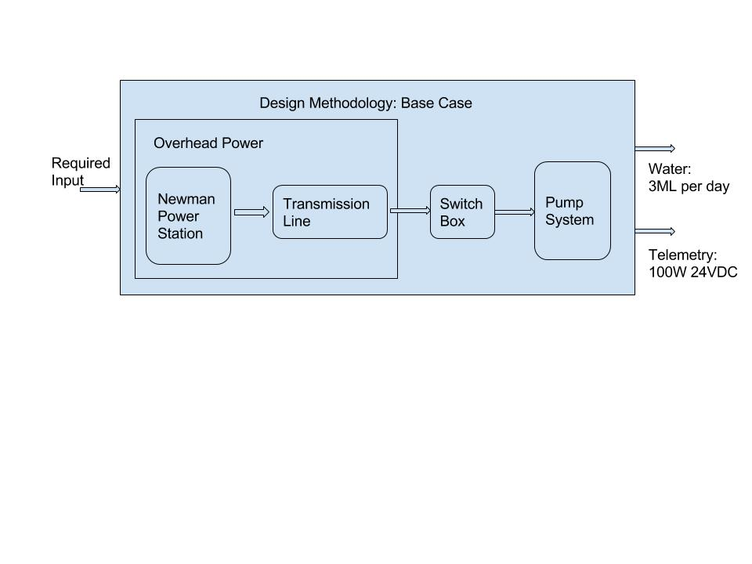
Figure 4: Base Case Line Diagram
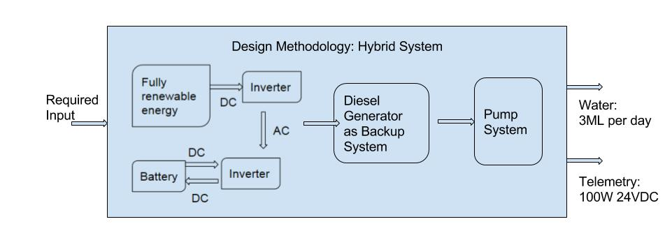
Figure 5: Hybrid System line diagram

Analysis and Evaluation
Currently, PV/wind system has become alternatives to satisfy environmental requirement and power supply. Because a multi-source power system can reduce the influence of location and weather, and increase the reliability of whole hybrid power system compared with the single renewable source. Particularly, when there is no wind (or solar), the supply of power can depend on the other renewable source. Even in the extremely bad weather no wind and solar, the power systems still have the backup battery to satisfy the electricity demand. HOMER software can carry out a better techno-economical simulation by using the hybrid system. Because these renewable sources bonded with battery storage could ensure the reliability of system [5].

Individual Learning Outcome
On the one hand, the ability of the project management can be fully practiced in the unit. Firstly, successful completion of any project requires a synthesis of in-depth planning, good design, proper execution and rigorous finalization. Moreover, project management techniques provide the tools with which to achieve this[7]. These include team meetings, creating agendas and taking minutes for meetings as well as attending meetings with the principle partner. Furthermore, developing a schedule (a detailed Gantt chart) improved team time management, tracking of work hours, on-time submission of group work etc. Work breakdown structure (WBS) can be applied to allocate the tasks, which ensured every team member can participate in this project. Generally, the whole workflow regarding this project can be shown in Figure 7;
On the other hand, it is useful for the author to practice and be familiar with the HOMER tool for the project in this unit. Because it trains the author the scientific research skills and guides author how to carry out a complicated project. In the meantime, the author has paid more attention on the team development and efficiency when the author was the chairperson. This is beneficial for author’s leadership skill to get a big promotion. In this project, what author learned was tried to find the optimal solution to address the proposed issue. In a real world, author also needs to consider the cost of the solution. It is hard to find the best solution at first. So the team discusses with each other and use results to test and confirm the optimal solution. Maybe the design system model got is not the best one, but with the comparison of different design models, author can learn the way of solving an engineering problem.

Appendices

Appendix A: Updated Requirements Priority Table including Classifications. EXP - Expecters, SPO - Spoken, UNS - Unspoken, EXC - Exciters
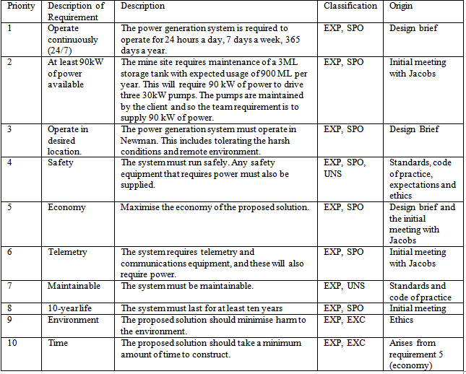

Appendix B: Climatic Information at Newman, WA
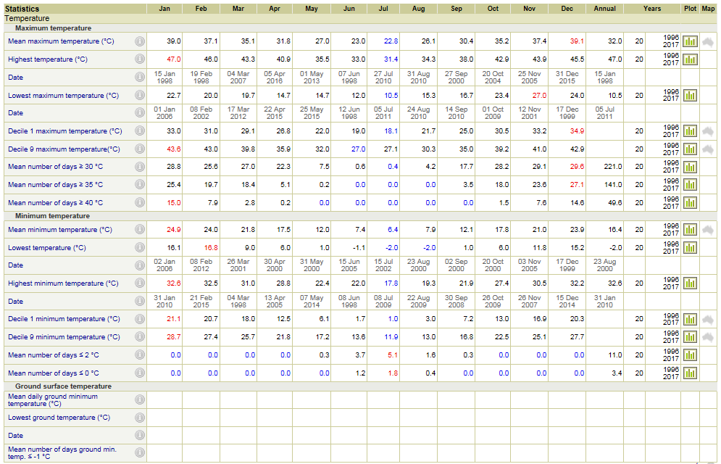
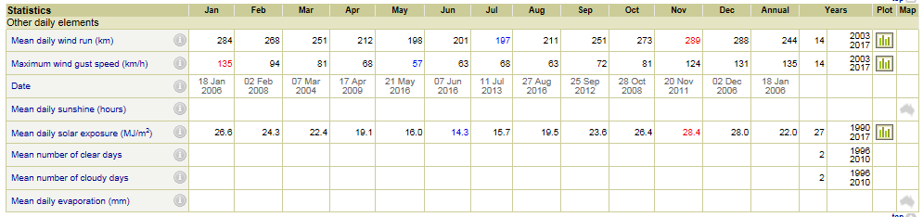

Appendix C: Technical Query
